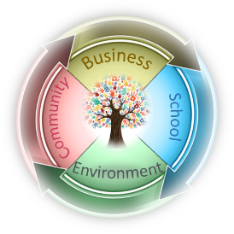
Full Circle School
Supply List 2021-2022 (Grades K-1)

Classroom supplies
- Pencil box labeled with student’s name
- Headphones (labeled with name or initials)
- 12 glue sticks
- 1 pair of safety scissors
- 24 pencils—sharpened, if possible
- 1 box of pencil top erasers
- Dry erase markers (3-4 pack)
- 8 count of markers (fine tip preferred)
- 24 count box of crayons
- 3 ring binder
- Box of size appropriate disposable face masks
- Yoga mat – new and returning students need a new one
- 3 pack of unscented baby wipes
- 1 container of sanitizer wipes (Lysol or store brand)
- Refillable water bottle (label w/child's name)
- Outside play shoes (close-toed) to keep at school
- Complete change of clothes in a gallon bag labeled with child’s name

**If your child will need a specific brand of sunscreen or bug spray, please provide it and make sure that the containers are labeled with your child’s name.

Wish List
None of these are required items. However, I often have parents ask if there are extra things we could use in our rooms. Extras of the following that can be donated at any time of the year

- Extra art supplies & sketch books
- Paper towels
- Sanitizer wipes OR disinfecting spray (such as Lysol spray)—must state that it kills 99% of viruses & bacteria on label
- Dishwashing soap
- Whiteboard markers
- Washable markers
- Construction paper
- Index cards
- Poster board
- Zip-lock freezer bags, gallon or quart
- Blank cards—for writing thank you notes or notes of encouragement

