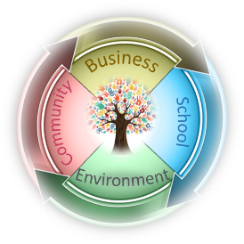
Upper Elementary Supply List
2021-2022 (Grades 3-5)

Classroom supplies
Be aware that if we open another class due to enrollment growth, the list of classroom supplies may change slightly. Changes in student placement after the school year begins can also affect needed supplies. However, there will not be huge changes and we will assist with any added items if you are unable to purchase or find them.
- Pencil pouch, pencil box, OR gallon bag for daily supplies (label with student’s name)
- Headphones or earbuds (labeled with name or initials)
- 3-ring binder (2 in.)—new students only
- 1 plastic 3 prong folder with pockets
- 12 pencils—sharpened, if possible
- 6-8 glue sticks
- Dry erase markers (3-4 pack)
- 4 highlighters (multicolor)
- Crayons OR colored pencils; whichever the student prefers (8, 12, or 24 pack)
- Box of size appropriate disposable face masks
- Yoga mat
- 3 pack of unscented baby wipes
- 1 container of sanitizer wipes (Lysol or store brand)
- Refillable water bottle (label w/child's name)
- Outside play shoes (close-toed) to keep at school
- Art supplies (sketch book, charcoal pencils, gum eraser, hand-held sharpener)

**If your child will need a specific brand of sunscreen or bug spray, please provide it and make sure that the containers are labeled with your child’s name.

**Additional equipment may be needed if your child is part of the equestrian program.

Wish List
None of these are required items. However, I often have parents ask if there are extra things we could use in our rooms. Extras of the following can be donated at any time of the year

- Extra art supplies & sketch books
- Paper towels
- Sanitizer wipes OR disinfecting spray (such as Lysol spray)—must state that it kills 99% of viruses & bacteria on label
- Dishwashing soap
- Whiteboard markers
- Washable markers
- Construction paper
- Index cards
- Poster board
- Zip-lock freezer bags, gallon or quart
- Paint for crafts
- Paint brushes or sponges
- Blank cards—for writing thank you notes or notes of encouragement

